Assignment 7 - DNA Replication and The Central Dogma of Biology

Part 1 – DNA Replication:
- To comprehend DNA replication, complete the table below.
DNA Replication
What is DNA replication?
This is the process by which DNA makes a copy of itself during cell division

Where in eukaryotic cells does DNA replication occur?
DNA replication occurs inside the nucleus

Where in prokaryotic cells does DNA replication occur?
DNA replication in prokaryotic cells occurs in the cytoplasm

When during the cell-cycle does DNA replication occur?
The phase of DNA synthesis

Why do cells need to replicate their DNA?
DNA must replicate before they undergo division. Allowing the daughter cells access to a copy of genome and facilitating successful inheritance of genetic traits.

- List the enzymes required to catalyze DNA replication in cells, and explain each enzyme’s function.
Enzyme | Function
DNA helicase | Unwinds the DNA double-helix by breaking the hydrogen bonds between complementary DNA strands of DNA.
DNA primase | The separation of double stranded DNA into single strands and thus facilitating copying of each strand.
DNA polymerase III | Its responsible for the duplication of the chromosomal DNA
DNA polymerase I | Processes RNA primers during lagging strand synthesis to fill the gaps in DNA repair
DNA ligase | Maintaining the genome intergrity by unifying the breaks in phosphodiester backbone of the DNA
DNA gyrase | Acts as a catalyst to the ATP dependent negative super coiling of double stranded closed circular DNA
- Create a diagram of a strand of DNA being replicated. The leading strand has the following/ DNA sequence, 5’-AGTTGTCCGATTGCGAAATTCGGTATA-
3’Label ALL of the following: leading strand, lagging strand, DNA helicase, DNA primase, RNA primer, Okazaki fragment, and DNA ligase.
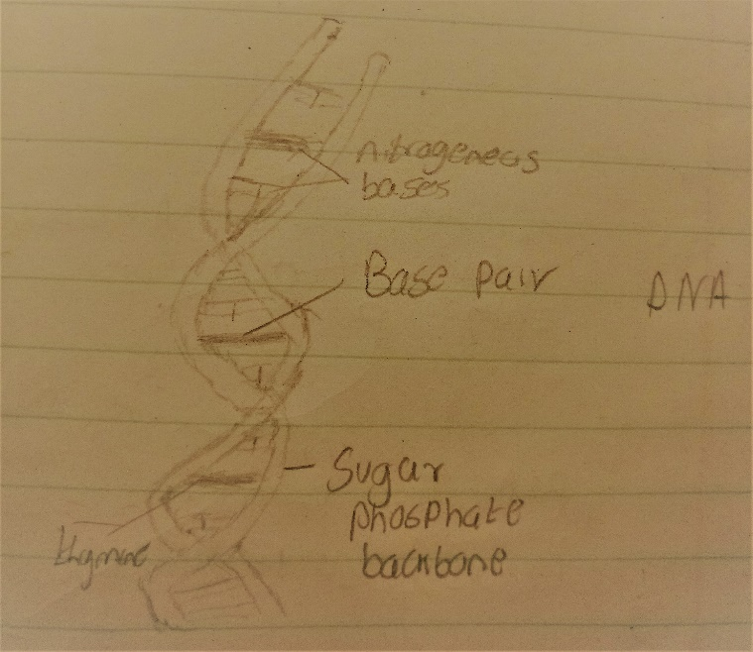

- Explain why DNA replication is a semi-conservative process.
The process involves two copies of the original DNA , each copy contains one original and another newly synthesized strand.
- If a cell has 46 chromosomes, after DNA replication is completed, the cell will have __84___ chromosomes.

Part 2 – The Central Dogma:

- Complete the following sentences by using the words in the word bank to fill-inthe-blanks.

Word Bank The Central Dogma of Biology is a process that describes how
  - Work cells ultimately create ______RNA________, which do all the
  - Proteins _____Formation_________ in cells. The instructions to make a protein
  - Nucleus are held in the _______nuclear membrane______, which are located in • Genes chromosomes in the _______molecules______ of eukaryotic cells.
  - Genome Prokaryotic cells do not have a nucleus, so their ________chromosome_______ is located in the nucleoid region in the cytoplasm. All organisms must use the processes outlined in the Central Dogma of Biology.

- Complete the followign graphic by illustrating an example of each part of the Central Dogma of Biology.
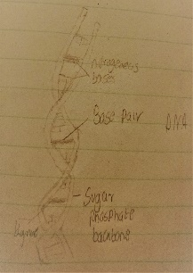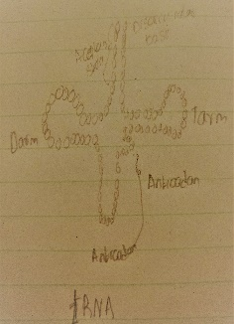

DNA

Transcription

Translation

mRNA

Protein

- To comprehend DNA replication, complete the table below.
Transcription
What is transcription?
Transcription is the process through which information in the DNA strand is copied into a new molecule of mRNA

Where in eukaryotic cells does transcription occur?
Nucleus

Where in prokaryotic cells does transcription occur?
cytoplasm

What enzyme is needed for create the mRNA transcript?
RNA polymerase 2

- Explain how RNA polymerase II knows where to start transcription of a gene. Use ALL of the following in your explanation: gene, promoter, transcription factors, RNA polymerase II, and transcription.
RNA polymerase II is a multi protein complex that facilitates transcription of DNA into MessengerRNA . it is one of the three RNAP enzymes located in the nucleus of eukaryotic cells. The genes involved in transcription by The RNAP 2 is bound by the nucleosomes. This is carried out through the creation of the means of recruits histone modifier and chromatin that remodels complexes that contribute te transcription initiation, elongation and termination
- In DNA, compare and contrast the template (non-coding) strand and non-template (coding) strand. Explain how are these strands different in the context of transcription?
The difference between the coding strand (non-template) and the new messengerRNA is that Thymine and Uracil take their place in the mRNA strand. The non-coding strand is transcribed into the mRNA whereas the coding strand is not transcribed into Mrna.The non-coding strand contains anticodon whereas the non-coding contains codon. The non-coding contains similar nucleotide sequence as the tRNA and the coding contains complementary nucleotide sequence as the tRNA
- Draw a diagram of a ribosome, and label ALL of the following: large subunit, small subunit, A-site, P-site, E-site.

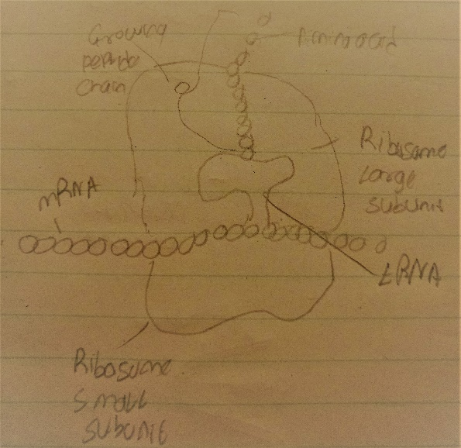
- Draw a diagram of a single transfer RNA (tRNA) holding a methionine amino-acid. Be sure the anti-codon is UAC, since the codon for methionine is AUG. Label ALL of the following: anticodon, amino acid, and tRNA
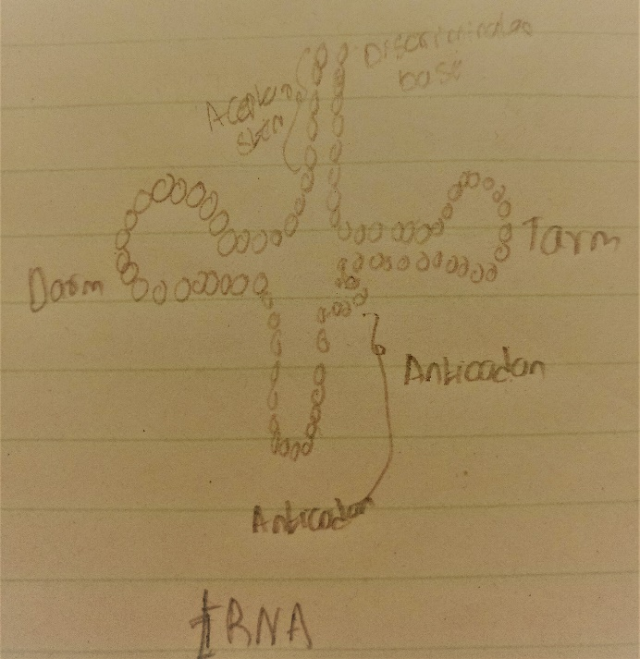

- List the DNA start and stop codons.
Start codon: _______AUG_________
Stop codons: ___________TAA_____________________

- Apply your knowledge of the Central Dogma of Biology to transcribe and translate the DNA sequences below.

Template strand  Complementary strand HFGGJHGJJMGHG  mRNA  NJHBGJ  Protein  HJGGK | 3’- TAC-TTC-CGA-AAT-TTA-GCT-ATT-5’
Template strand  Complementary strand  HJGOJJPOK  mRNA  JKLHKYUGTUI  Protein  KUHGUGOL | 3’- TAC-GGG-CCC-CAT-TAC-TCC-ATC-5’
Template strand | 3’- TAC-ACT-CAC-GCC-TTA-TGC-ACT-5’

Complementary strand
HJGHJB
mRNA
JGHLKJ;PK
Protein
JKHKPO;KK

